Crofton Infants School
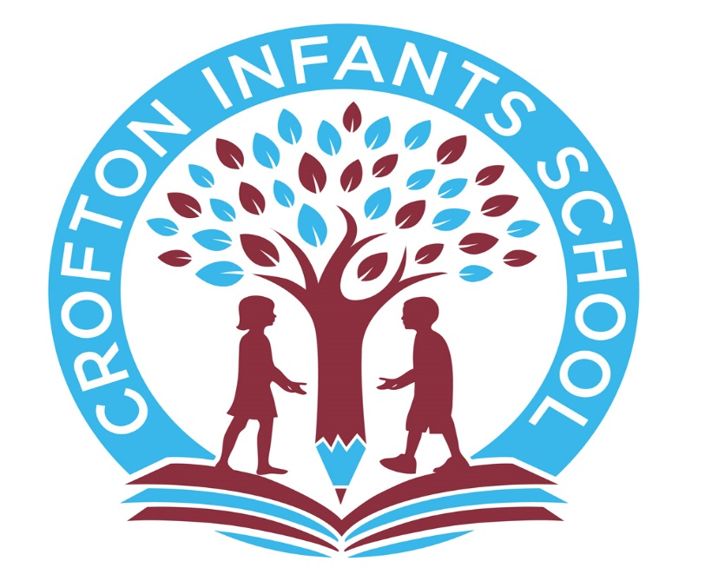

Early Years Part Time Charging Policy

Crofton Infants School offers term time, sessional funded places for children aged 3 and 4 years old. In addition to this, the school offers parents the option of taking 15 additional funded hours per week based upon the extended entitlement or ’30 hours’ scheme.

Funded universal 15 hours can be taken by parents at the following times:

Morning session 8.30am – 11.30 am
OR
Afternoon session 12.15pm – 3.15pm

These sessions are Monday to Friday during term time only.
Crofton Infants School is currently offering extended entitlement or 30 hours at the following times:

Monday to Friday school term time only 8.30am – 2.30pm
As the nursery session and school day finishes at 3.15pm parents can choose to pay for an extra 45 minutes at the end of the day ( 2.30pm – 3.15pm).
Where a parent wishes to cancel either funded or paid for sessions, a period of 2 weeks notice is required.

Charges:
The extra part of the child’s additional session 2.30pm to 3.15pm ( 45 minutes each day) is chargeable at the following rate:

The 45 minutes rate is £3.00
A full week is therefore £15.00
Charges will still be applicable should a child be absent for whatever reason.

If a parent becomes ineligible for the additional funded hours, the place will be withdrawn at the end of the ‘Grace Period’.

The school may request a deposit of £10 for an additional hours place if demand is high. This will be refunded as part of the first invoice once a child has taken up their place. Failure to take up the additional hours booked will mean the deposit becomes non-refundable.

Invoices:
Parents will receive their invoice at the end of the month for the previous months payment and will be expected to pay this by the due date. Payment should be by BACS transfer.
Admission/Availability:
The school will allocate universal 15 hours places based on our Early Years Admissions Policy. Places for children eligible for 30 hours will be allocated on a first come first served basis. No guarantee can be made that a parent will receive the additional sessions they request, however we will always do our upmost to meet need.

Sundries:
Children taking up the 30 hours entitlement must bring a packed lunch each day. The school does not make a specific weekly charge for the food that children eat at snack time or for baking ingredients.
Children who receive the additional 15 hours of care will be entitled to one carton of milk during their universal 15 hours and will be offered water during their extended session.
Events such as educational visits and visitors in to school are subsideised through fund raising activities alongside a request for a voluntary contribution from parents to cover part of the costs.

Name | C Holloway
Designation | Executive Headteacher
Effective from | September 2023
Approved by | ASC
Approved meeting ref: | September 2023
Next review: | September 2024

